1. **Agenda**:
   1. Let’s enhance our app to use the JWT tokens instead of default generated ones (JSESSIONID)
2. 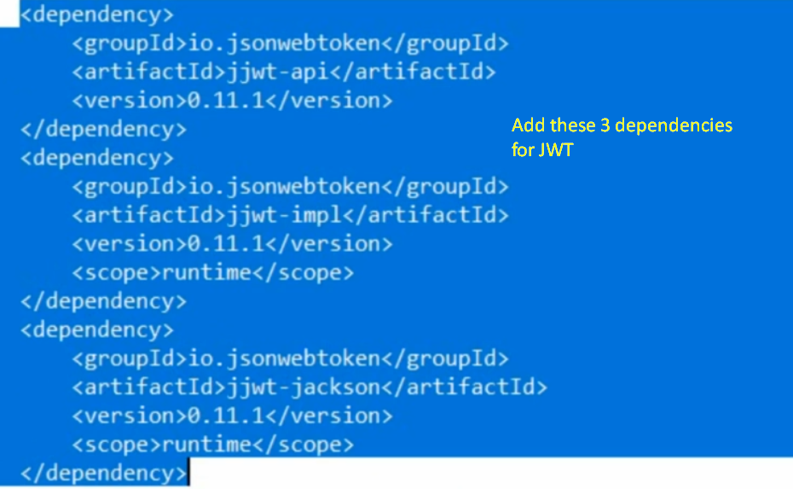
3. 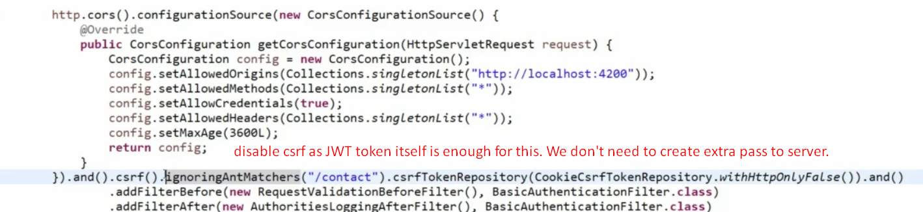  
   **Disabling CSRF**: As JWT token in not maintained as cookie so CSRF attack is not possible. Because cookies are automatically submitted along request.
4. 
5. 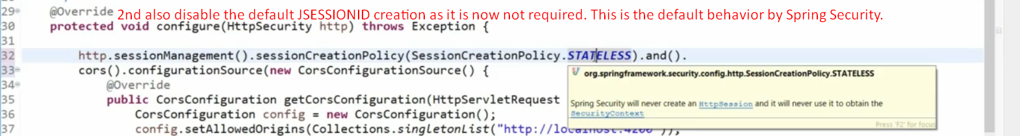
6. 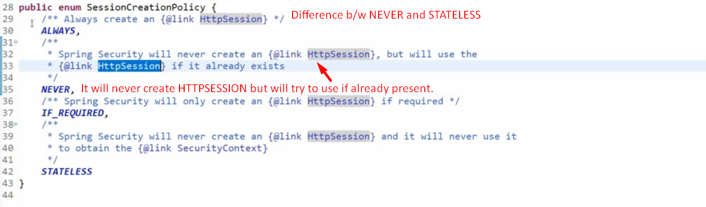
7. Now, we’re going to generate a JWT token then send inside the header with name “Authorization” and its value would be JWT.  
   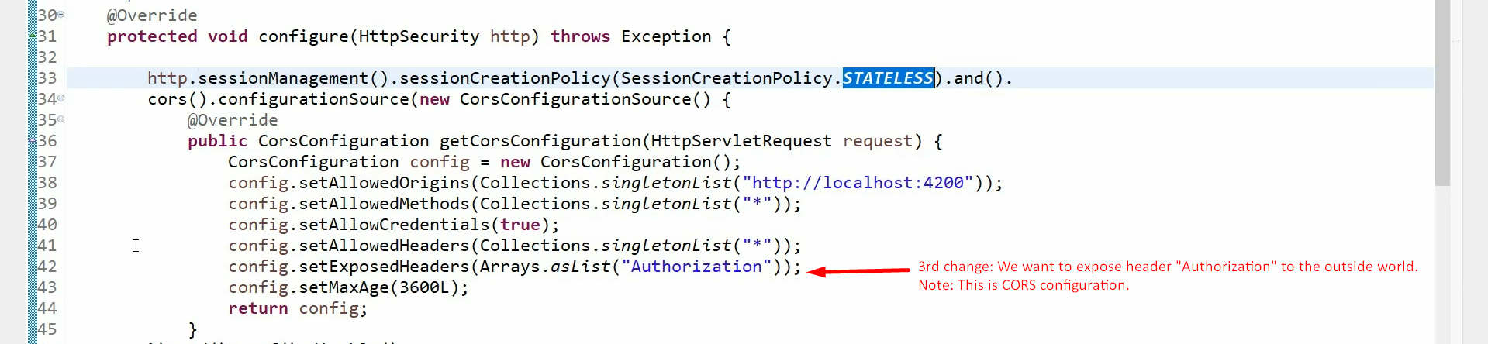
8. 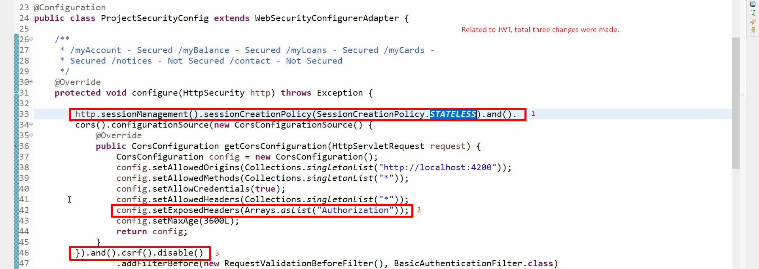
9. In next lecture, let’s add filter to generate and validate JWT token.